WH&S Management Plan

Purpose

This purpose of this plan is to:

* ensure a safe working environment through safe actions and proper planning
* respect the health and safety commitment to all on the premises

This plan will assist AIE in meeting its obligations in accordance with work health and safety legislation.

This plan applies to all AIE’s employees and to other persons at risk from work carried out at AIE’s workplaces. Failure to comply with the requirements of this Plan may lead to disciplinary action.

Work Health and Safety (WHS) Policy

The Statement of Commitment and the Implementation of Policy Commitment provide the overarching direction AIE will follow in pursuit of workplace health and safety outcomes. These commitments are:

**Statement of Commitment**

AIE is committed to providing a workplace that enables all work activities to be carried out safely. We will take all reasonably practicable measures to eliminate or minimize risks to health, safety and welfare of workers, contactors, visitors, and anyone else who may be affected by our operations.

We are committed to ensuring we comply with the *Work Health and Safety Act 2011* (the Act). We will also comply with any other relevant legislation, applicable Codes of Practice and Australian Standards as far as possible.

**Implementation of Policy Commitment**

AIE is committed to ensuring, so far as is reasonably practicable, the health and safety of its workers while they are at work, and that the health and safety of other persons is not put at risk from our operations. This will be achieved by:

* providing a safe working environment
* ensuring there are fire extinguishers available in all areas
* training staff to properly respond to hazards
* holding drills to practice safe evacuation

Duty of Care

A Person Conducting a Business or Undertaking (PCBU) has the primary duty of care to ensure:

* the health and safety of workers or people on premises
* that no one on the premises is put into hazardous situations through PCBU work

AIE is a PCBU.

Responsibilities

**Managers and Leaders**

Managers and leaders are responsible for providing a workplace that is, as far as reasonably practicable, a safe and healthy workplace for workers and visitors, in particular in the areas of their control. This includes:

* modelling health and safety leadership
* demonstrating a commitment to good health and safety performance
* co-operating with workers and always improving upon current safety management
* keeping workers up to date with information, instruction, and training

**Workers**

Workers must take reasonable care for their own health and safety while they are at work, and take reasonable care that their acts or omissions do not adversely affect the health and safety of other persons.

On a day to day basis, this includes:

* ensuring their own personal health and safety, and that of others in the workplace
* complying with any reasonable directions (such as safe work procedures, wearing personal protective equipment) given by management that relates to health and safety
* not misusing or interfering with anything related to health and safety
* reporting concerns, accidents, and hazards

It is acknowledged that, in accordance with the Act, a worker may cease, or refuse to carry out work if they have a reasonable concern the work would expose the worker to a serious risk to their health and safety.

**Contractors**

Contractors, sub-contractors and self-employed persons are defined as “workers” under the WHS Act if they carry out work in any capacity for AIE. They are required to:

* follow the regulations of the WHS legislation
* co-operate with the business to comply with their policies and not endanger their staff

**Health and Safety Experts**

The following is a list of nominated workplace health and safety experts, who may be called on to assist with any aspect of this workplace health and safety management plan.

* Alexandra Mannell – Deputy Head of School

WHS Risk Assessment:

The purpose of any WHS risk assessment is to ensure that, for any identified hazards, appropriate control measures are implemented in order to protect workers, contractors and visitors from risks to their health, safety and welfare.

Control measures for WHS hazards should be implemented as required using the following hierarchy of control, in order of preference these measures relate to:

* elimination (removal of the hazard)
* substitution (substitute the hazard for something which is less hazardous e.g. replace a hazardous chemical with one within is not hazardous)
* isolation (isolate the hazard from people e.g. place a noisy piece of equipment in another location)
* engineering (e.g. guarding on machinery)
* administrative (e.g. provision of training, policies and procedures, signage)
* personal protective equipment (e.g. use of hearing, eye protection, high visibility vests).

Outcomes of risk assessments will be documented and the control measures reviewed at least annually or earlier should a task or activity be the subject of a WHS incident or a change of process or requirement. Current risk assessments will ensure that AIE achieves the goal of eliminating or minimising the risk workers may be exposed to.

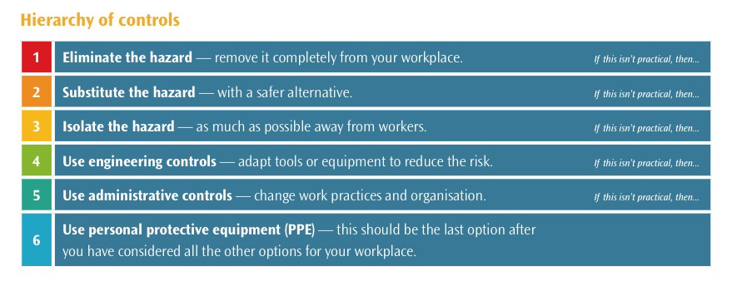

Hazard and Risk Assessment:

|  |  |  |  |  |  |
| --- | --- | --- | --- | --- | --- |
| Consequence | LIKELIHOOD | | | | |
| Very Unlikely (1) | Unlikely (2) | Possible (3) | Likely (4) | Very Likely (5) |
| Catastrophic (A) | M | M | H | VH | VH |
| Major (B) | L | M | M | H | VH |
| Moderate (C) | L | M | M | M | H |
| Minor (D) | L | L | M | M | M |
| Insignificant (E) | VL | VL | L | L | M |

|  |  |
| --- | --- |
| Risk level | Required action |
| Very High | Act immediately:  The proposed task or process activity must not proceed. Steps must be taken to lower the risk level to as low as reasonably practicable using the hierarchy of risk controls. |
| High | Act as soon as possible:  The proposed activity can only proceed, provided that:  (i) the risk level has been reduced to as low as reasonably practicable using the hierarchy of risk controls;  (ii) the risk controls must include those identified in legislation, Standards, Codes of Practice etc.  (iii) the risk assessment has been reviewed and approved by the Supervisor and  (iv) The supervisor must review and document the effectiveness of the implemented risk controls. |
| Medium | Act when not too busy:  The proposed task or process can proceed, provided that:  (i) the risk level has been reduced to as low as reasonably practicable using the hierarchy of risk controls;  (ii) the risk assessment has been reviewed and approved by the Supervisor. |
| Low | Act when there is free time:  Managed by local documented routine procedures which must include application of the hierarchy of controls. |
| Very Low | Keep a watching brief:  Although the risk level is low the situation should be monitored periodically to determine if the situation changes. |

|  |  |  |  |
| --- | --- | --- | --- |
| Hazard | Consequence | Likelihood | Risk Level |
| Hand in vending machine compartment | Insignificant – minor | Possible | Low |
| Spreading sickness | Minor – moderate | Possible | Medium |
| Liquid or obstacle near stairs | Minor – catastrophic | Unlikely | Medium |
| Liquids near electronics | Minor – catastrophic | Unlikely | Medium |
| Wet restroom floor | Minor – catastrophic | Possible | Medium |
| Electrical fire | Major – catastrophic | Very unlikely | Low |
|  |  |  |  |
|  |  |  |  |
|  |  |  |  |
|  |  |  |  |
|  |  |  |  |
|  |  |  |  |
|  |  |  |  |
|  |  |  |  |
|  |  |  |  |

|  |  |
| --- | --- |
| Workplace location: | Wentworth Park Grandstand, Wattle St, Ultimo NSW 2007 |
| Name of person conducting assessment: | William Beaven |
| Date: | 19/03/2020 |

|  |  |  |  |  |  |  |  |  |  |  |
| --- | --- | --- | --- | --- | --- | --- | --- | --- | --- | --- |
| S | Spot the hazard | | A | Assess the risk | F | Fix the problem | | | E | Evaluate results |
| Identify the work task or activity | | What are the hazards associated with each activity or the steps in each activity | Is the risk associated with the task very low, low, medium, high or very high? | | If the risk is deemed unacceptable for the task, what will be done to reduce or remove the risk? | | By whom? | By when? | Go through the first 3 steps again to ensure risk levels are now at an acceptable level | |
| Revised risk level | |
| Working with keyboard and mouse | | Touching a surface that might others have touched | Medium | | Clean keyboard and mouse before use | | User/  cleaner | Every day | Very low | |
| Using many computers at once | | Lots of power being used, electrical fire | Low | | Proper cable management/check for tangles | | AIE staff | Every few months | Very low | |
| Using the restroom | | Slipping on floor and falling | Medium | | Mop the floor | | Cleaner | When ever possible | Very low | |
|  | |  |  | |  | |  |  |  | |
|  | |  |  | |  | |  |  |  | |

Training Plan for Workers:

AIE is committed to providing appropriate training to ensure workers have the skills and knowledge necessary to fulfil their WHS obligations. WHS training is a fundamental requirement for AIE to achieve a safe workplace.

The following induction checklist should be used in conjunction with the general induction training program for workers to ensure that all new workers are aware of the WHS systems, policies and procedures in place within AIE.

|  |  |
| --- | --- |
| Workplace: Academy of Interactive Entertainment | |
| Date: 19/03/2020 | Completed by: William Beaven |

|  |  |  |  |  |
| --- | --- | --- | --- | --- |
| Control measures | What training is required? | Who is to be trained? | How? | Date completed |
| Building evacuation | Fire drill and evacuation training | All AIE staff members & students | Knowledge of exit routes and meeting points | Immediately |
| First aid & CPR | First aid & CPR course | All AIE staff | Taught proper technique | Immediately |
| Drinks/food on desks | Teacher discussion | Students/  staff | Discussion on possibilities and dangers | First week |
| Bullying | N/A | Staff and students | Discussion on AIE WHS policies | First week |
|  |  |  |  |  |
|  |  |  |  |  |
|  |  |  |  |  |
|  |  |  |  |  |
|  |  |  |  |  |
|  |  |  |  |  |
|  |  |  |  |  |
|  |  |  |  |  |